## **Directed Graphs**

### **3.1. Definition of Directed Graphs**

Directed graphs are a class of graphs that don’t presume symmetry or reciprocity in the edges established between vertices. In a directed graph, if a and b are two vertices connected by an edge (a,b), this doesn’t necessarily mean that an edge connecting (b,a) also exists:

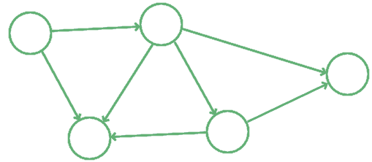

Directed edges are normally represented as arrows pointing away from the origin vertex, or tail of the arrow, and towards a destination vertex, or head of the arrow. Directed graphs are the most general kind of graphs because they don’t impose the restrictive assumption of symmetry in the relationship modeled by the edges.

### **3.2. Common Usages for Directed Graphs**

This type of graph is also typical for the modeling of certain kinds of real-world structures. The most common directed graph is probably the genealogical or phylogenetic tree, which maps the relationship between offsprings and their parents.

In a family tree, each vertex can at the same time be a parent and an offspring in different relationships, but not simultaneously in the same one:

Copy of Blank Diagram1

It wouldn’t make sense for an individual to simultaneously be the parent and the child of another individual. As a consequence, the graph which represents family trees must necessarily be a directed graph.

## **4. Undirected Graphs**

### **4.1. Definition of Undirected Graphs**

Undirected graphs are more specific. For them, there’s an extra assumption regarding the reciprocity in the relationship between pairs of vertices connected by an edge. If an edge (a,b) exists between two vertices a and b, the edge (b,a) also exists:

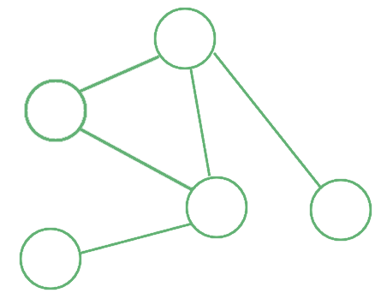

Undirected graphs are, in a sense, more restrictive than directed graphs, because they don’t allow the modeling of relationships that have a hierarchical nature. They’re however very common in practice, and many real-world relationships are best modeled by undirected graphs. This is normally the case if both vertices of an edge can be the subjects of that relationship.

For instance, the relationship “is a friend of” is a typical symmetric relationship. This is because we can assume that if “Mark is a friend of John” then it’s also true that “John is a friend of Mark.” Notice how this wasn’t the case for the relationship “is a parent of” described earlier.

### **4.2. Common Usages for Undirected Graphs**

One of the most popular undirected graphs in computer science is the topology of connections in a [computer network](https://www.baeldung.com/java-netty-http-server). The graph is undirected because we can assume that if one device is connected to another, then the second one is also connected to the first:

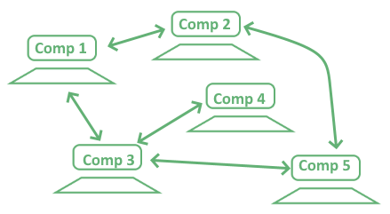

Other popular examples of undirected graphs include the topology of digital social networks, where each friend of someone is that someone’s friend; but also pedestrian pathways, where movement between any two intersections of paths is possible in both directions.

### **4.3. Symmetrical Directed Graphs Are Undirected Graphs**

We can now give another definition of undirected graphs. This definition is constructed on the basis of the one for directed graphs and depends on it. **A graph is undirected if its adjacency matrix is symmetric along the main diagonal**.

If we use this definition, we can then find the single undirected graph that corresponds to any given directed graph. This is important because it then allows us to compare the two classes of graphs in information-theoretic terms.

Note that the opposite is not necessarily the truth, in the sense that more than one directed graph can correspond to the same undirected graph:

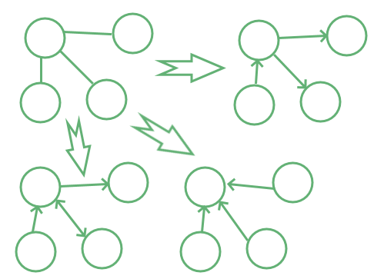

In our definition, two adjacency matrices D and U of, respectively, a directed graph and an undirected graph, correspond to one another if D_{(i,j)}=1 and U_{(i,j)}=U_{(j,i)}=1, and also if for all (i,j) such that D_{(i,j)}=D_{(j,i)}=0 implies that U_{(i,j)}=U_{(j,i)}=0.

If the two matrices satisfy this condition, we can then use Shannon’s measure of entropy to compare the two graphs.

## **5. The Entropy of Directed vs Undirected Graphs**

### **5.1. Under What Conditions Can We Compare Them?**

The condition defined above and which we follow for this section is very restrictive. It implies that the two graphs we’re comparing, the directed and undirected graph, include the same vertices.

They don’t necessarily include the same edges though. Simply, the undirected graph has two directed edges between any two nodes that, in the directed graph, possess at least one directed edge.

This condition is a bit restrictive but it allows us to compare the entropy of the two graphs in general terms. We can do this in the following manner.

### **5.2. A Comparison of Entropy in Directed and Undirected Graphs**

Let’s assume that e is the number of directed edges in the directed graph D. The corresponding undirected graph U has a number of edges that varies between e, if D is symmetric, and 2e, if no two edges of D have opposite direction.

Let’s call d = \{d_1, d_2, ... , d_{N^2}\} the random binary variable associated with the adjacency matrix D of the directed graph; and u = \{u_1, u_2, ... , u_{N^2}\} the random binary variable associated with the adjacency matrix U.

If e edges of D exist out of the total possible N^2, then the entropy H(d) of d is:

H(d) = - ( \frac{e}{N^2} \cdot log ( \frac{e}{N^2}) + (1-\frac{e}{N^2}) \cdot log (1- \frac{e}{N^2}))

The entropy H(u) of u is equal to H(d) if D is symmetric. If D has no opposite edges, though, H(u) is equal to:

H(u) = - ( \frac{2e}{N^2} \cdot log ( \frac{2e}{N^2}) + (1-\frac{2e}{N^2}) \cdot log ( 1-\frac{2e}{N^2}))

We can consider these two cases as the extremes in a distribution of possible graph structures. Let’s now see how the two measures of entropy compare for a reference graph with N=10 vertices:

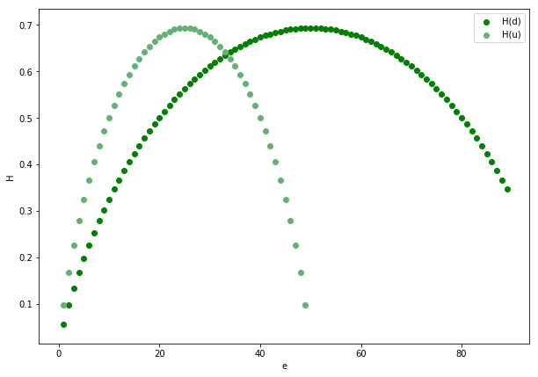

The figure above shows that, with the exception of e = 2e = 0 and e = 1-2e = \frac{N^2}{3}, in general H(d) \neq H(u). This means that we can’t, as a general rule, treat directed graphs as undirected graphs or vice-versa. If we do, we normally pay a price in terms of their information content.

## **6. When to Choose One Over the Other**

We can finally sum up what we learned about directed and undirected graphs. Here are some indications on how to choose which type to use:

* Directed graphs are more informative than corresponding undirected graphs when the network is sparse. This means that if we treat a sparse directed graph as undirected we probably lose information
* Directed graphs apply well to model relationships which are directional and not reciprocal in nature. A good example is a relationship “is a child of”, upon which we construct genealogical trees
* Undirected graphs apply well to relationships for which it matters whether they exist or not, but aren’t intrinsically transitive. If, for example, we can go both ways in pedestrian paths, then we can model the pathways as an undirected graph
* We can model the same system as a directed graph in some circumstances and as an undirected graph in others. For example, we can represent a family as a directed graph if we’re interested in studying progeny. If we’re studying clan affiliations, though, we can represent it as an undirected graph

Directed and undirected graphs are, by themselves, mathematical abstractions over real-world phenomena. As a consequence, a programmer should choose carefully which one to apply to a problem. The graph needs to correspond to the type of relationships which we model: undirected if it’s reciprocal, directed otherwise.

## **7. Conclusions**

In this article, we’ve seen what’s the difference between directed and undirected graphs. Directed graphs have edges that are directional and not necessarily reciprocal. **If a vertex in a directed graph is connected to another, that doesn’t necessarily mean that the second is also connected to the first.**

Undirected graphs are more restrictive kinds of graphs. **They represent only whether or not a relationship exists between two vertices. They don’t however represent a distinction between subject and object in that relationship.**